Calculus 30
Chapter 4 – Differentiation Practice Test
1. Find the derivative of the following using the Definition of a Derivative Formula.

Find the Derivative for each using the Power Rule, Product Rule, Quotient Rule or
Chain rule. DO NOT SIMPLIFY!!
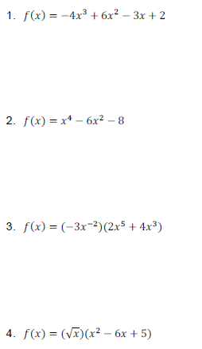

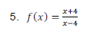

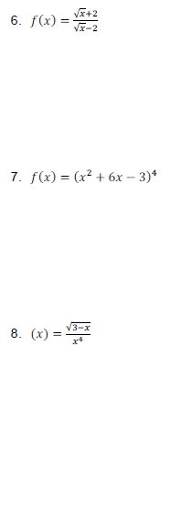
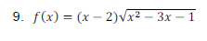

10. Find an equation of the tangent line to the curve at the given point.
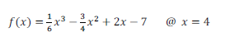

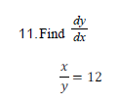

b)$y^{2}-3xy=-2$

c) $x^{2}-xy^{2}+y^{2}=4$

12. Determine the derivative. Answer must be in simplified form.
a) $f\left(x\right)=\left(x^{3}-7x\right)\left(9x^{2}+3\right)$

b) $y= {\left(2x+1\right)}^{3}{(x^{2}-5)}^{5}$

c) $f\left(x\right)= \frac{x^{3}-4x^{2}}{x+1}$

d) $y={\left(x-1\right)}^{2}(\sqrt{2x+1})$

13. Find the coordinates the point(s) on the graph of $f\left(x\right)=x^{3}-3x^{2}-6x+10$ at which the slope of the tangent line is 3.

14. The line y = 4 is tangent to the function y = x² + ax + b at the point (5,4). Determine the values of a and b.

