Calculus 30
Chapter 7 – Differentiating Transcendental Functions
Practice Assessment
PART A: Logarithmic and Exponential Functions
- Write the following as a single logarithm.
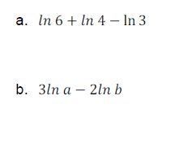
- Solve the following equations. Answers must be in exact form, not decimals.
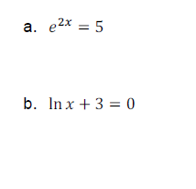
- Find the derivative of the following functions:
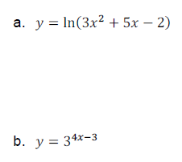

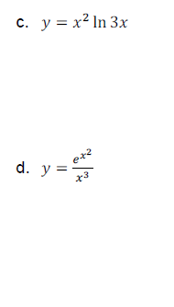
e. $f\left(x\right)=\log_{4}{(5x+6)}$

f) ${f\left(x\right)=e}^{{(7x-2)}^{3}}$

- An ingot of steel is removed from a furnace. Its surface temperature, T, in degress Celsius, t minutes after removal is 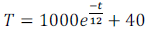. Find the rate of change of the temperature after 10 minutes. Interpret this result.

PART B: Trigonometric Functions
- Solve the following Limits
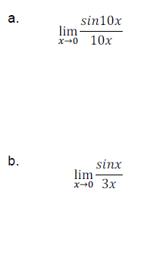
6. Determine the derivative of the following. Answers do not need to be simplified.
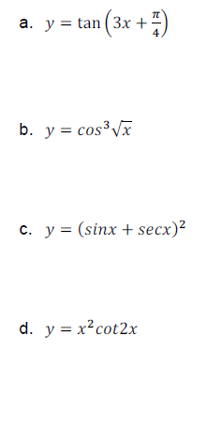
7. Determine the slope of the tangent line to
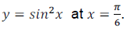

8. Use implicit differentiation to solve for dy/dx if $x=3y+siny$.

9. Over the interval (0,π), determine the values of x for which the tangent line to the curve of $f\left(x\right)=sin2x-2sinx$is horizontal. It will be helpful to use the identity $cos2x=2\cos^{2}x-1$ at some point in your solution.

