Calculus 30: Chapter 5 Exam Review
- Determine f’(x) and f”(x) for the following functions
- $y=6x^{4}+5x^{3}-8x$

- $f\left(x\right)=\sqrt[3]{3x^{2}-4}$

- For the given graph:
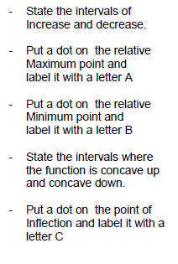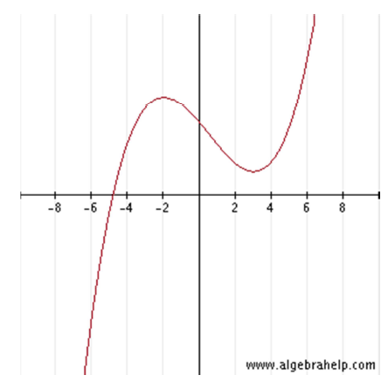

- Without graphing, determine the absolute extrema of the following function in the given interval
$f\left(x\right)= 4x^{3}-12x-5$ ; x є [-3,3]

- For the following function determine
- The critical numbers
- The intervals in which the function is increasing/decreasing
- The intervals in which the function is concave up/down
- The coordinates of any relative extrema
- $y=x^{3}+6x^{2}-15x+90$

- $y=2x^{3}-x^{4}$

- $f\left(x\right)= \frac{x^{2}}{x+2}$

- For the following function, find the following.
- a sign analysis of $f^{'}\left(x\right)$
- the intervals on which $f(x)$ is increasing and/or decreasing
- the critical numbers
- the relative extrema
- a sign analysis of $f^{''}(x)$
- the intervals on which $f(x)$ is concave up and concave down
- the coordinates of any inflection points
- the $x$and $y$ intercepts
- the equations of any vertical and horizontal asymptotes
- a careful sketch of the function
- $y=\frac{x}{x^{2}-1}$

- a sign analysis of $f^{'}\left(x\right)$
- the intervals on which $f(x)$ is increasing and/or decreasing
- the critical numbers
- the relative extrema
- a sign analysis of $f^{''}(x)$
- the intervals on which $f(x)$ is concave up and concave down
- the coordinates of any inflection points
- the $x$and $y$ intercepts
- the equations of any vertical and horizontal asymptotes
- a careful sketch of the function

- $f\left(x\right)=2x^{3}-3x^{2}-12x$

- a sign analysis of $f^{'}\left(x\right)$
- the intervals on which $f(x)$ is increasing and/or decreasing
- the critical numbers
- the relative extrema
- a sign analysis of $f^{''}(x)$
- the intervals on which $f(x)$ is concave up and concave down
- the coordinates of any inflection points
- the $x$and $y$ intercepts
- the equations of any vertical and horizontal asymptotes
- a careful sketch of the function

- $f\left(x\right)=\frac{2x^{2}}{x^{2}+12}$

- a sign analysis of $f^{'}\left(x\right)$
- the intervals on which $f(x)$ is increasing and/or decreasing
- the critical numbers
- the relative extrema
- a sign analysis of $f^{''}(x)$
- the intervals on which $f(x)$ is concave up and concave down
- the coordinates of any inflection points
- the $x$and $y$ intercepts
- the equations of any vertical and horizontal asymptotes
- a careful sketch of the function

- $y=3x^{5}-10x^{3}$

- a sign analysis of $f^{'}\left(x\right)$
- the intervals on which $f(x)$ is increasing and/or decreasing
- the critical numbers
- the relative extrema
- a sign analysis of $f^{''}(x)$
- the intervals on which $f(x)$ is concave up and concave down
- the coordinates of any inflection points
- the $x$and $y$ intercepts
- the equations of any vertical and horizontal asymptotes
- a careful sketch of the function

- $y=\frac{3x}{{(x+1)}^{2}}$

- a sign analysis of $f^{'}\left(x\right)$
- the intervals on which $f(x)$ is increasing and/or decreasing
- the critical numbers
- the relative extrema
- a sign analysis of $f^{''}(x)$
- the intervals on which $f(x)$ is concave up and concave down
- the coordinates of any inflection points
- the $x$and $y$ intercepts
- the equations of any vertical and horizontal asymptotes
- a careful sketch of the function

- $f\left(x\right)=3x^{\frac{2}{3}}-x^{2}$

