University of Saskatchewan Scholarship Information/Application Procedures
- Enter website www.usask.ca then click Undergraduate Programs
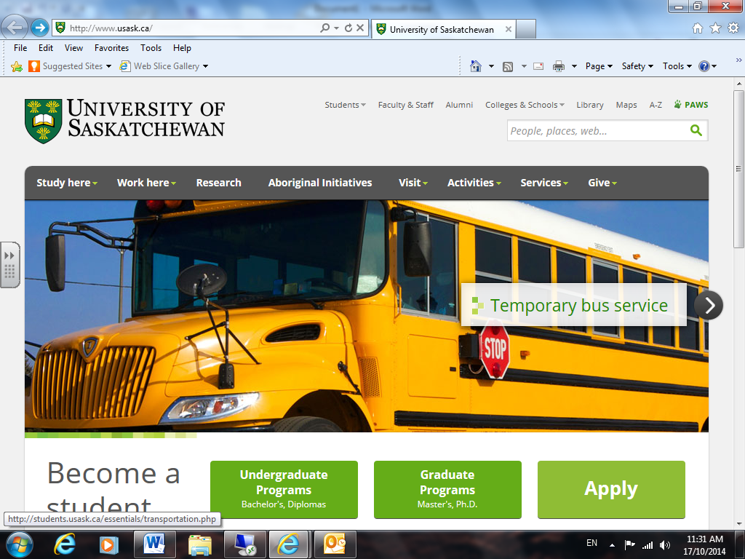
- Under Money Matters tab, click on Scholarships and Awards
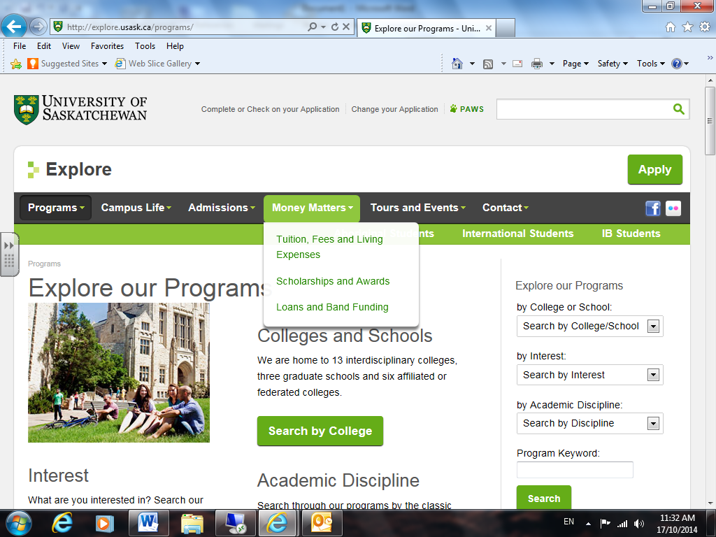

- Using Search Awards, enter program information then search
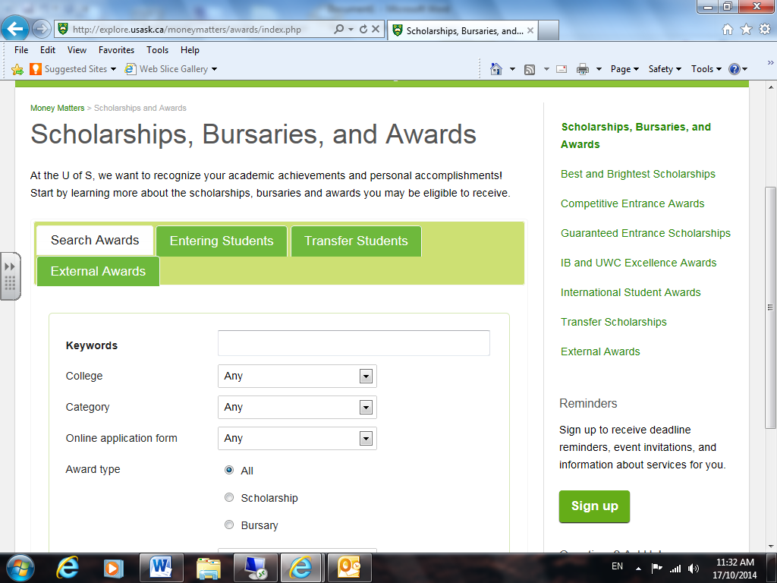
- Using Entering Students tab, investigate various scholarship opportunities
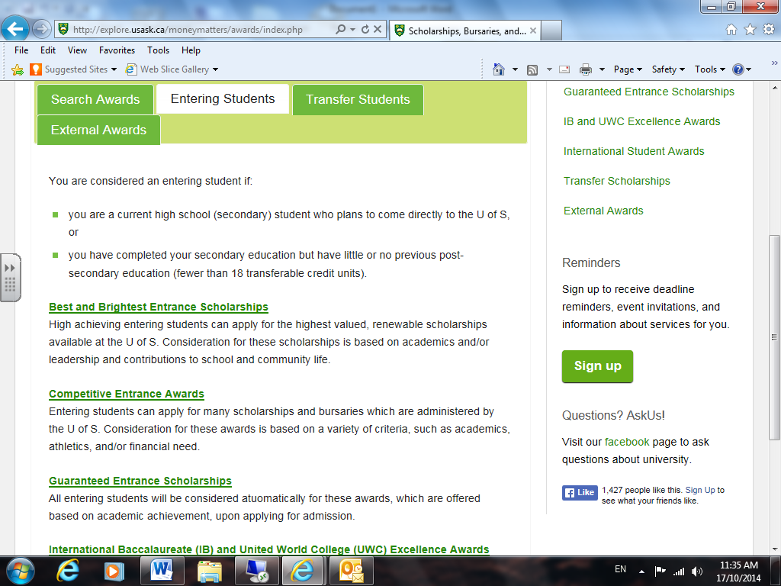

- Under External Awards tab, students can also investigate a number of other scholarship links.
