University of Regina Scholarship Information/Application Procedures
- Enter website www.uregina.ca then click Future and New Students tab.
- Locate Money Matters tab and click enter.
- Click on Scholarships and Awards tab.
4.Click on tab to inquire about various scholarship options, deadlines, and criteria.
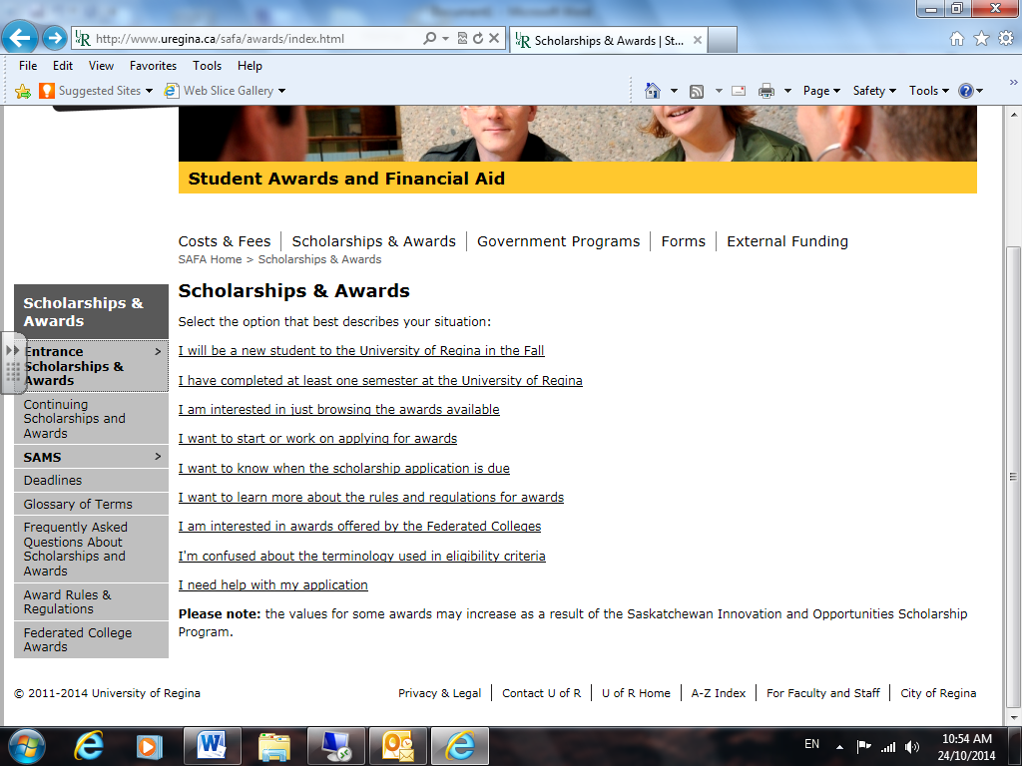
5.Click tab on type of scholarship you are inquiring about.
6. All new students are eligible for Automatic Entrance Scholarships. If interested in other scholarships, click on the Application Required Entrance Scholarships and Awards tab.
