SIAST( Saskatchewan Polytechnic) Information/Application Procedures
- Enter website http://saskpolytech.ca then click Admissions tab.
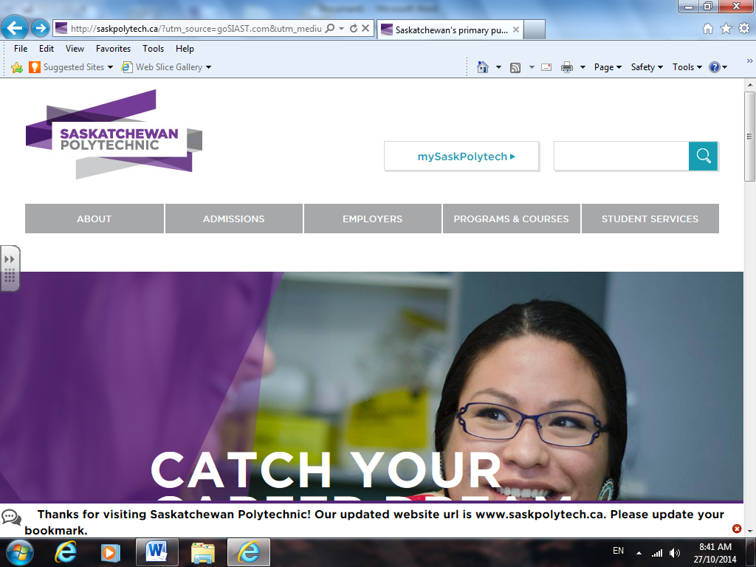
- Under Admissions, click Resources then Financial Assistance.

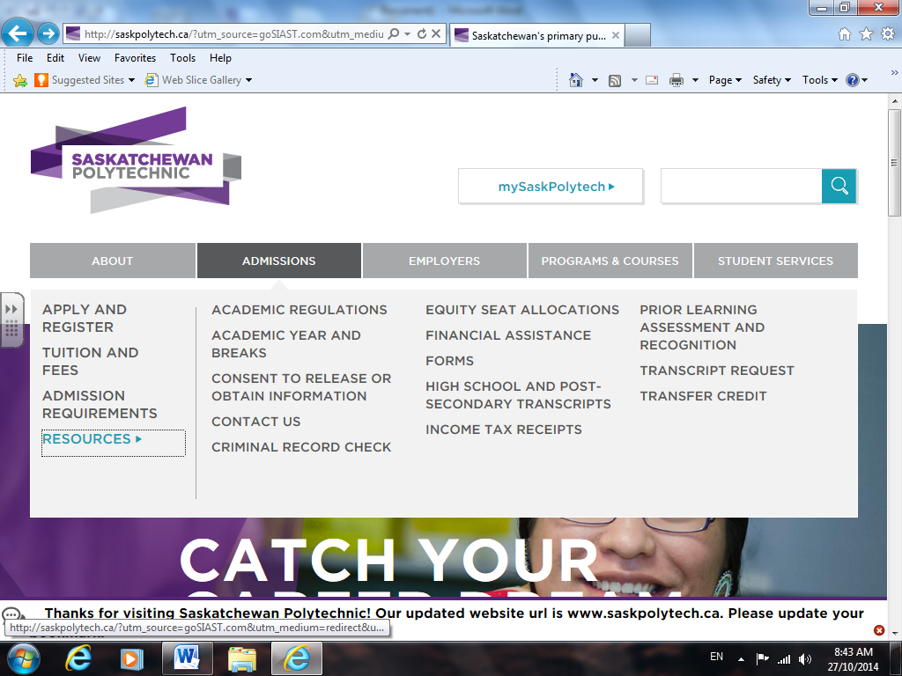
- Under Financial Assistance, select Scholarships and Awards.
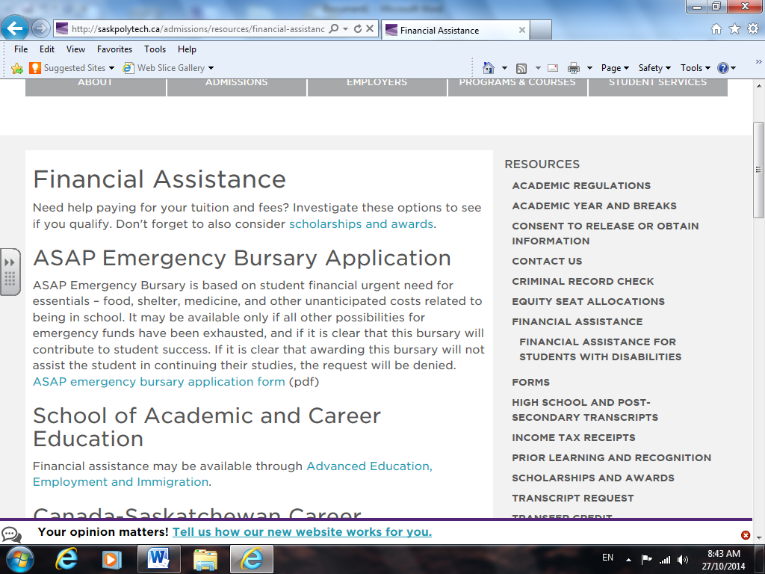

- Review information then scroll down to Click Here and Apply Now.
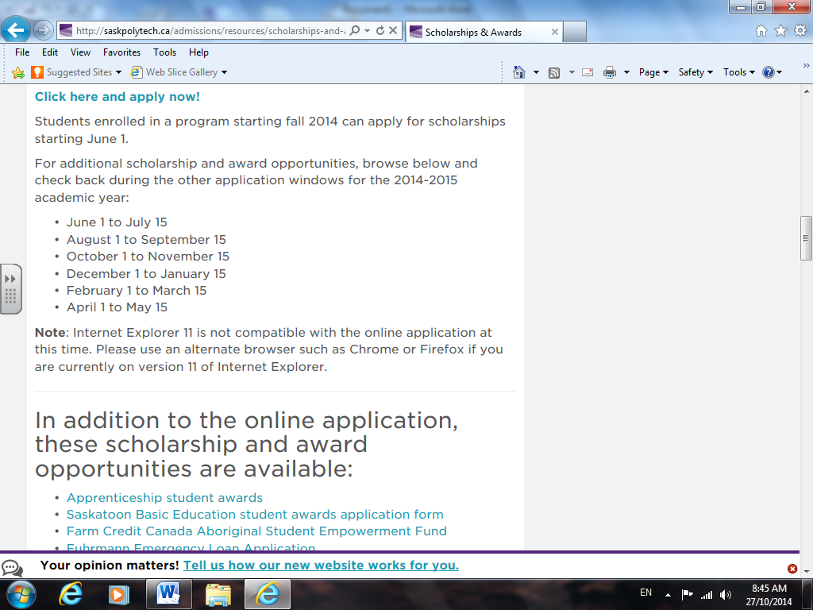

- On the previous page, if you continue to scroll down, additional scholarship resources are available. These are all worth exploring if qualified to apply.
