Career Education 9 Name:___________________________

CG9.1 Plan for, demonstrate, and document improvements of one’s own capacity for building a positive self-image.

ABOUT ME: Fill in the charts below with examples specific to you. State at least 3 examples in each column of the chart.
Dreams about my future | Values | Interests and Hobbies
Think about: your hopes and aspirations, your long-term goals | e.g. honesty, respect | Think about: what you like doing in your spare time, what you are naturally good at

HOW I VIEW MYSELF: Decide if the following qualities are: always, sometimes or never like you and check the corresponding boxes in the chart below.
Quality | Always | Sometimes | Never
I AM RELIABLE
I AM PUNCTUAL
I AM HONEST
I AM POSITIVE
I AM HARDWORKING
I AM HAPPY
I AM KIND
Quality | Always | Sometimes | Never
I AM STUBBORN
I AM CREATIVE
I AM INTELLIGENT
I AM SELFISH
I AM OUTGOING
I AM CONFIDENT
I AM LOYAL
I AM HUMOUROUS
I AM FRIENDLY
I AM CAPABLE
I AM WITHDRAWN
I AM CURIOUS
I AM AMBITIOUS
I AM COMPULSIVE

HOW I VIEW MYSELF – REFLECTION QUESTIONS:
From “how you view yourself”, list the words that you rated never:
What does this say about you? Are you proud of this rating?

From “how you view yourself”, list the words that you rated always:
What does this say about you? Are you proud of this rating?

MY TIME MANAGEMENT SKILLS – REFLECTION AND REVISION:
Do you think you have “good” time management skills? What are you good at?

What’s working?
- I can always find my_______________________________________________________
- No matter how busy I get, I always find time for_________________________________
- Do your time management skills need improvement? ____________________________
- My goals are well defined when it comes to __________________________________________

Reflect back on how you spent the last five days. Do you think you spent your time “wisely”? Why or why not? Support your answers with specific examples.

What’s not working?
- I can never find my ________________________________________________________
- I have no place to put my ___________________________________________________
- I don’t have enough time for ________________________________________________
- I procrastinate whenever I have to ___________________________________________

Are there activities/tasks that you should have completed in the last five days that you did not complete? If so, why did you not complete these activities/tasks?

Are there activities/tasks that you completed in the last five days that you are proud of? If so, was it easy or difficult to find the time to complete these activities/tasks?

Login to http://myblueprint.ca/.

You should have a screen that looks similar to this:
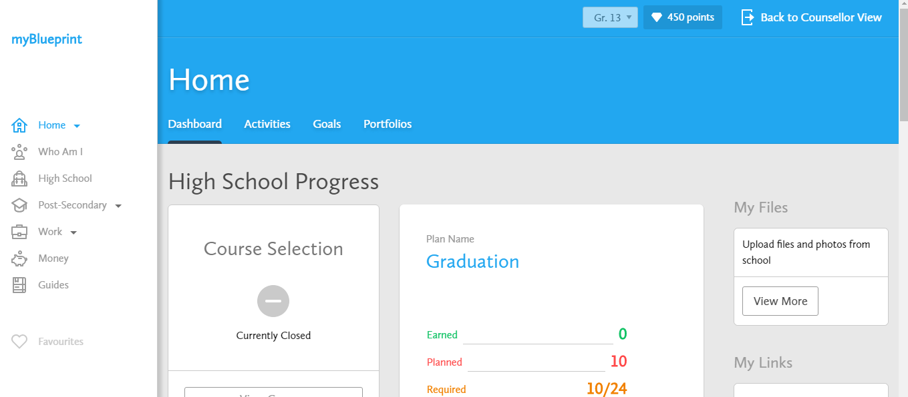

Take a few minutes to explore the site; especially the four tabs on the Home Screen. (Dashboard, Activities, Goals, Portfolios)

Select the tab “Who Am I” and you will see a “Survey” section and a “Match Results” section. Completing these surveys will help you to find out what your areas of interest are and to prepare you for the future.

You are to work through the 5 surveys. As you complete a survey you will see a green checkmark. The last thee surveys will “unlock” once you complete the first 2.

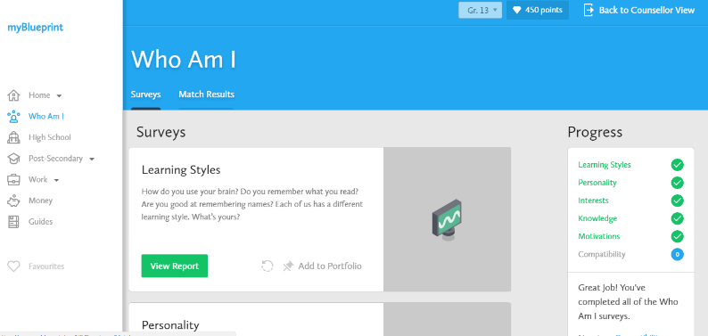

When you have finished all 5 surveys list 3 things you learned about yourself while doing these surveys:

1)

2)

3)

Now Select “Match Results”

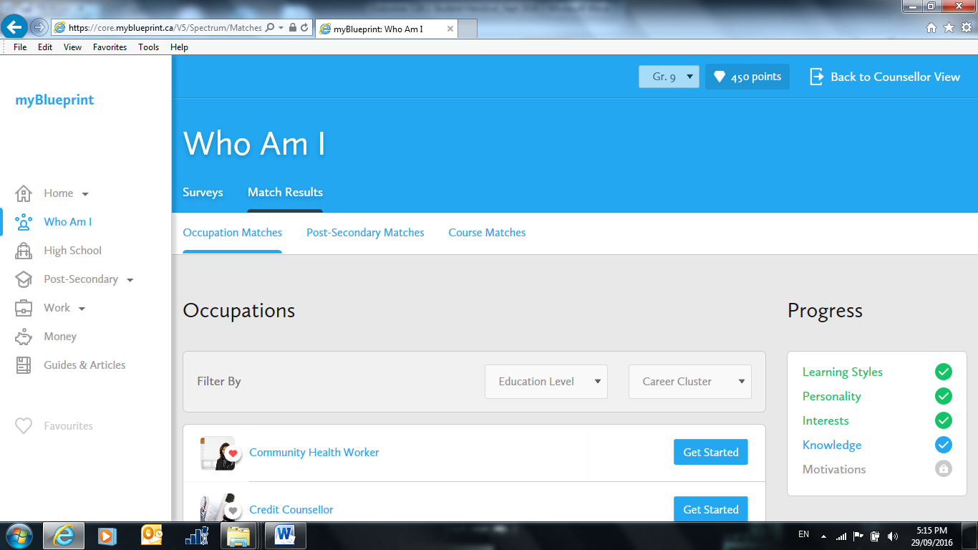

Your top occupation interests are shown.

Choose at least 3 of these and click on the “get started” button for each. (You can look through all of them if you wish!) Answer the questions to see if you are a match to that profession. Don’t rush through this step!

Did any of the careers you are thinking about pursuing show up? If yes, which one(s)? If no, did any seem interesting to you?

_________________________________________________________________________________________________
Setting Goals
Example and Non examples of SMART goals:
ARE YOUR GOALS S.M.A.R.T.?
S – Specific: “Do well in Math” “Reach level 3 in Math”
M – Measureable: “Get healthy” “Exercise for 30 minutes twice a week”
A – Achievable: “Bank $500,000 a month” “Bank 10% of what I earn this year”
R – Realistic: “Become a rock star” “Learn how to play the guitar”
T – Timely: “Finish Halloween costume” “Finish Costume by October 15”
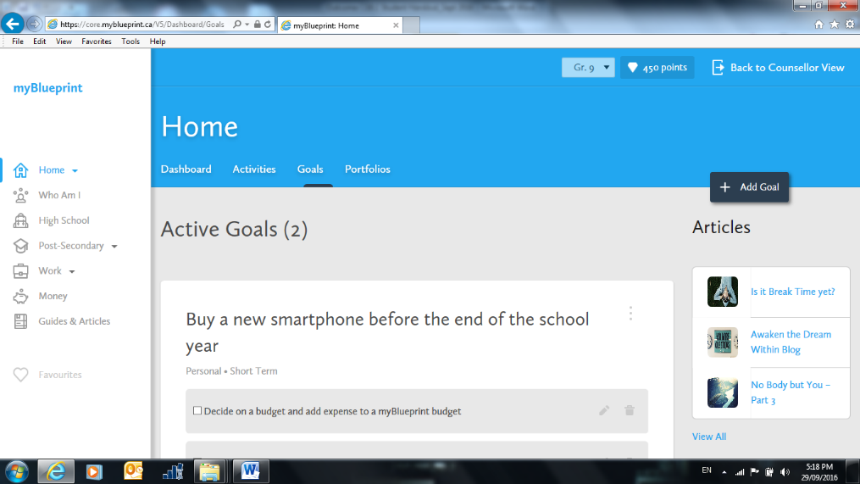
Go to your home page and select “Goals”

Your screen should look similar to:

Click on “+ add goal” and browse through your choices.

You can make your own goal or choose from some of the example provided.
Add at least 3 goals, one at a time. You must have at least three DIFFERENT goal types and at least one goal under EACH different timeframe. (You can make more than 3 goals!) You need a goal description; such as “I want to learn to play the guitar” and then you enter how you will achieve your goal; ie. “I will sign up for guitar lessons

Reflection
Why is it important to consider individual characteristics when planning for and achieving career and life goals?

In describing myself to a potential employer, I would give myself a _______________ (on a scale of 1 – 10) because….

Three positive things I could tell a possible employer about myself would be:

1)

2)

3)

Three things I may have to work on the help me get a job would be:

1)

2)

3)

An employer would see me as having a positive/negative self image because ….

You are now completely done outcome CG9.1 Please hand in completed handout to your teacher. You can now use any time left in class to explore MyBlueprint so you can see what you might like to do in your future.

