STEP ONE – ASSESSMENTS (This gives students ideas about possiblities for the future based on who they are)
Begin by clicking on three bars(top left-hand corner), beside “Home” to get a drop down menu.
If you are in grade 9, click on “Discovery” and complete the assessment.
If you are in grades 10-12, click on “Explorations” and complete the assessment.

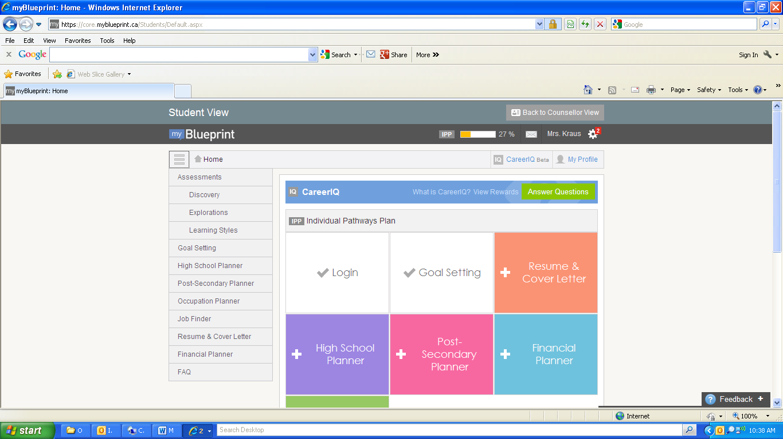

Return to three, bars drop down menu in top, left-hand corner.
All students in grades 9-12, click “Learning Styles” and complete assessment

STEP TWO – POST-SECONDARY PLANNER (Click on “post-secondary planner)
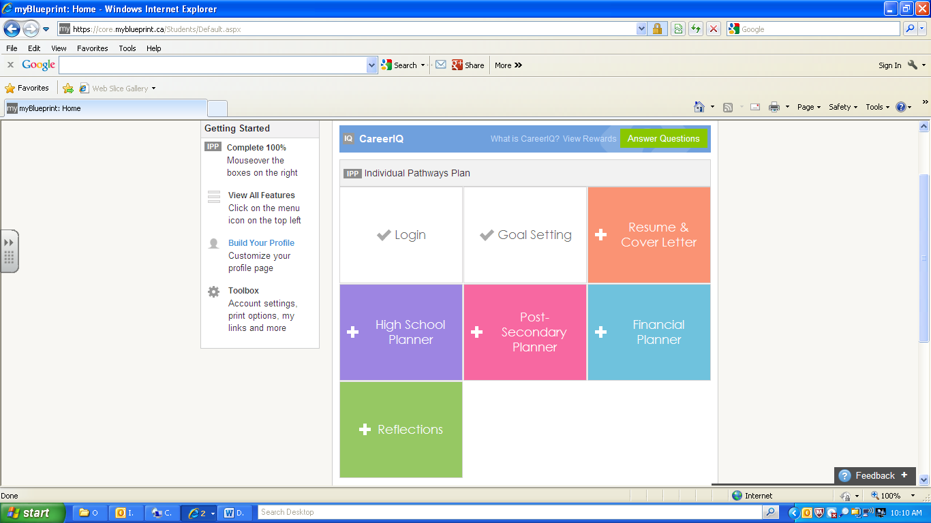

This is what you will see……

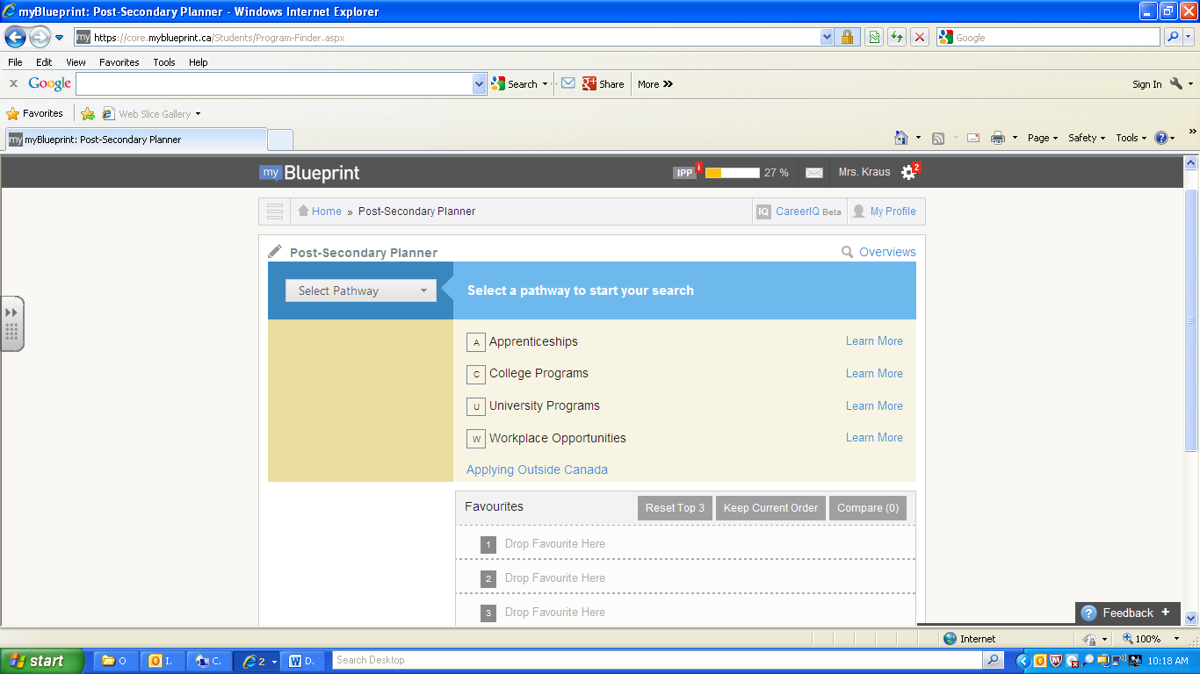

Select a pathway by pulling drop arrow down…
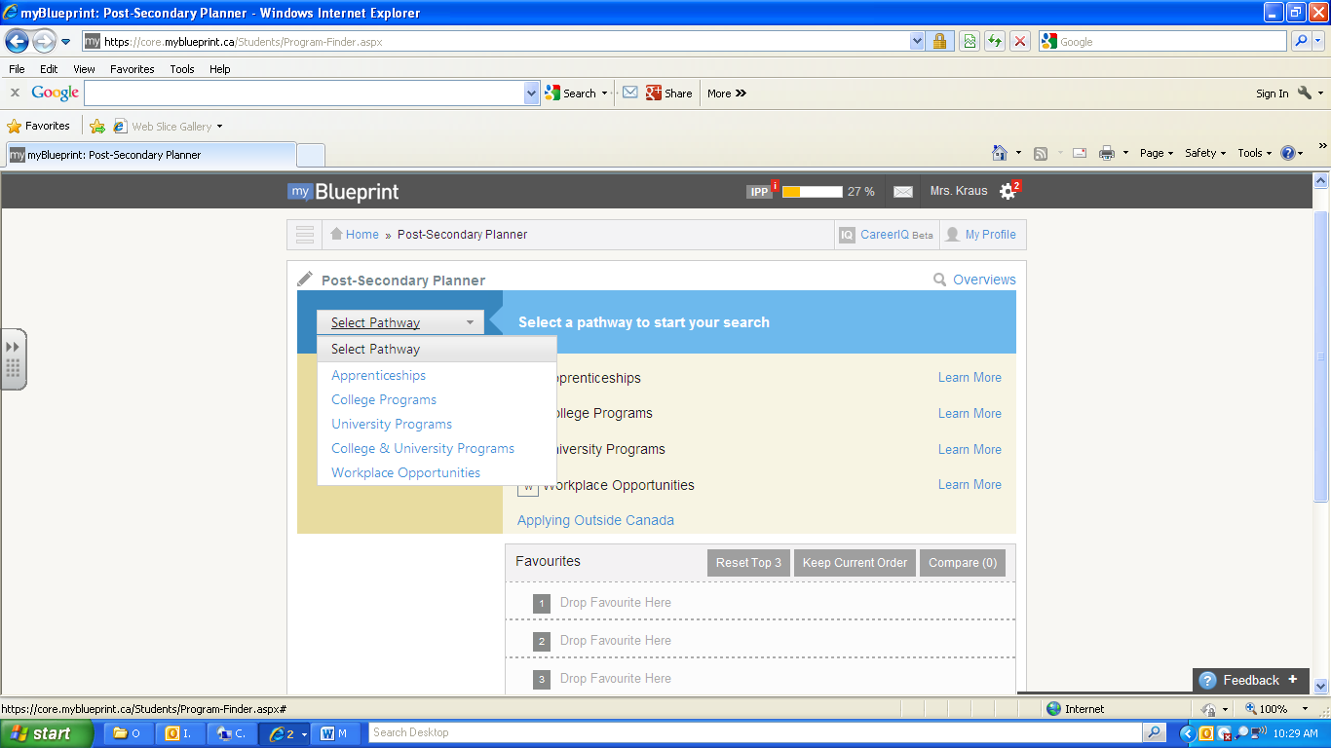
Apprenticeship (Carpentry, Construction, Welding, Chef, Mechanic etc)
College Programs (Technical and Trade Schools ie SIAST, Diplomas and Certificates Earned)
University Programs (Degrees Earned)
College and University Programs (College and University Combined Programs)
Workplace Opportunities (Jobs)
Enter opportunity name or keyword (Suggestions from Discovery, Explorations of Learning Styles Could Be Used)
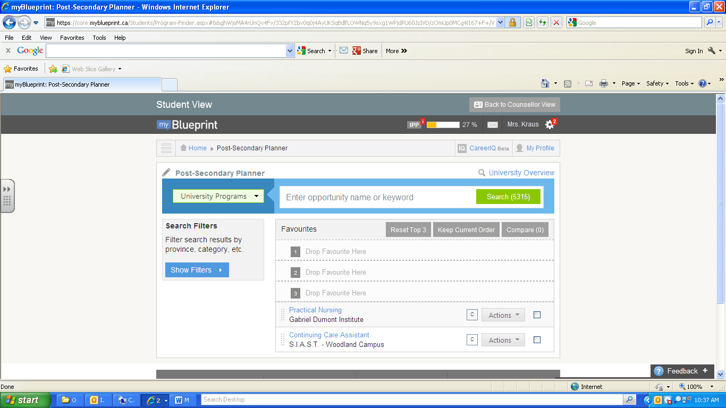

Example “Nursing” and click “Search” in green
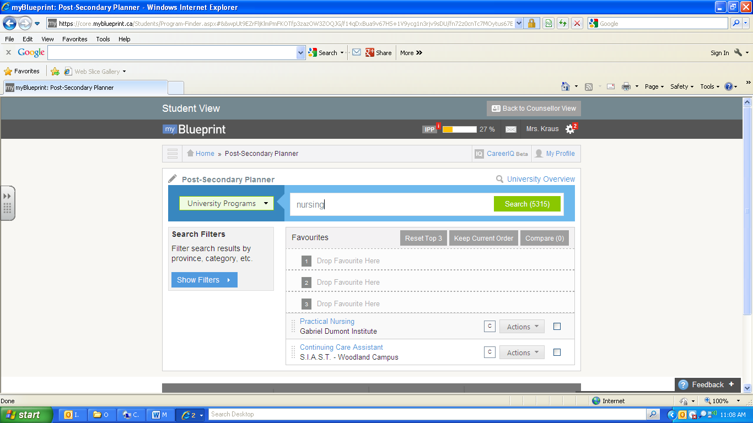
This shows 163 options for univeristy Nursing in Canada
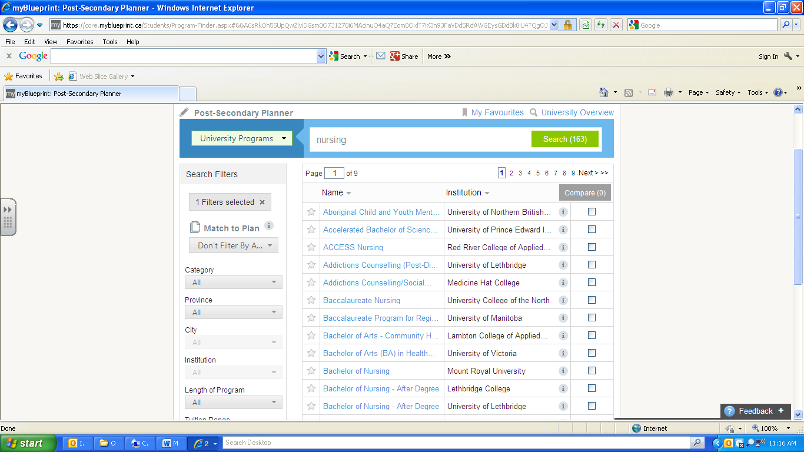

Your search can be narrowed by province (Now there are 7 university nursing options in saskatchewan) and click on your option in blue

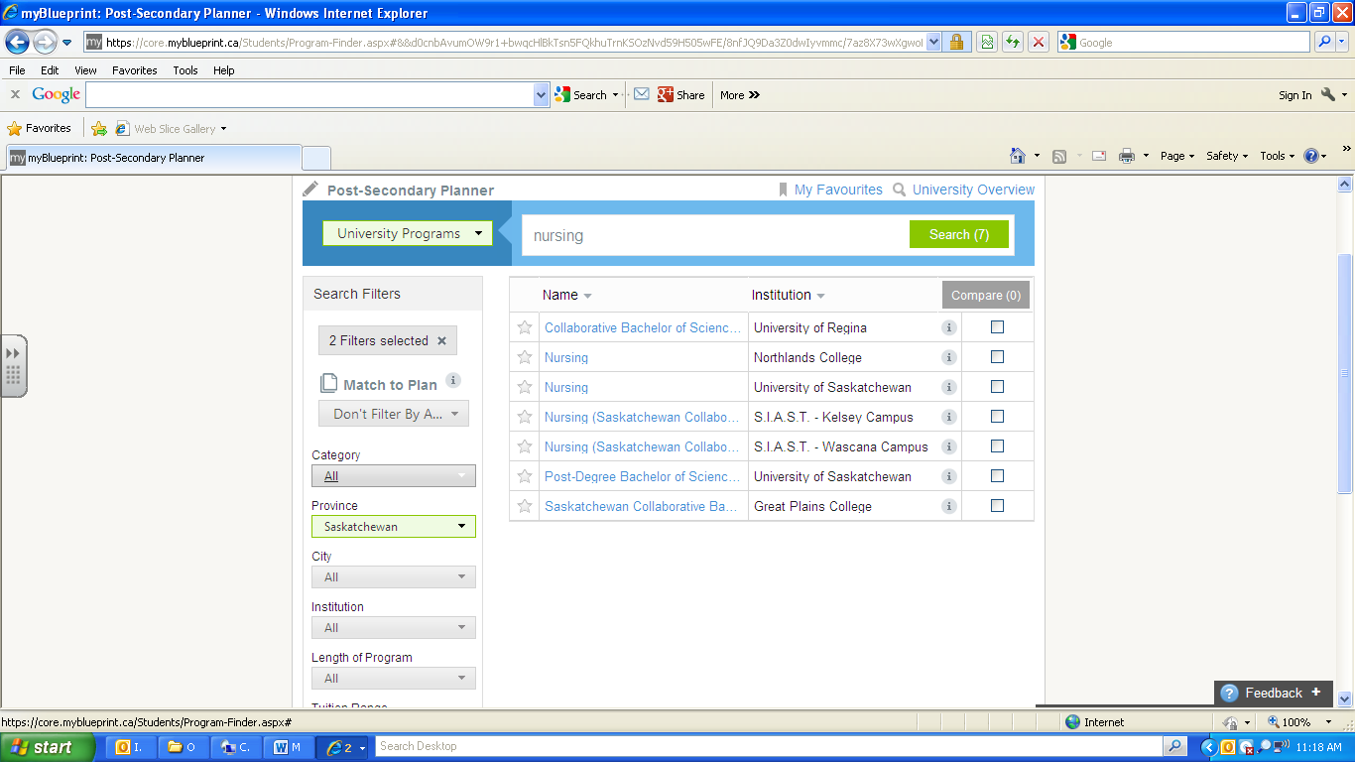

This begins by giving an “overview” of the program

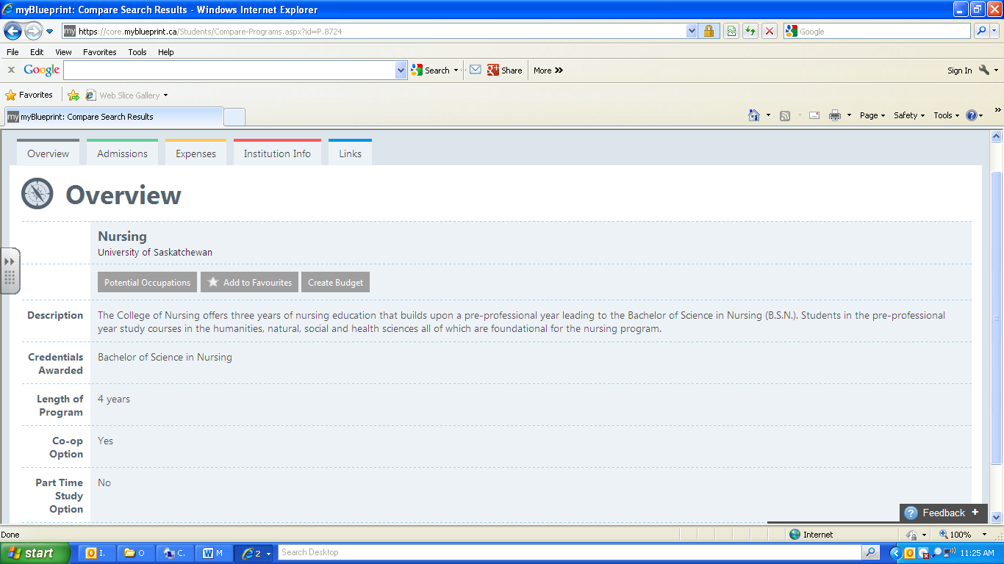

Click on “Admissions” (Tells You Classes You Need To Take In High School; Access to Application)
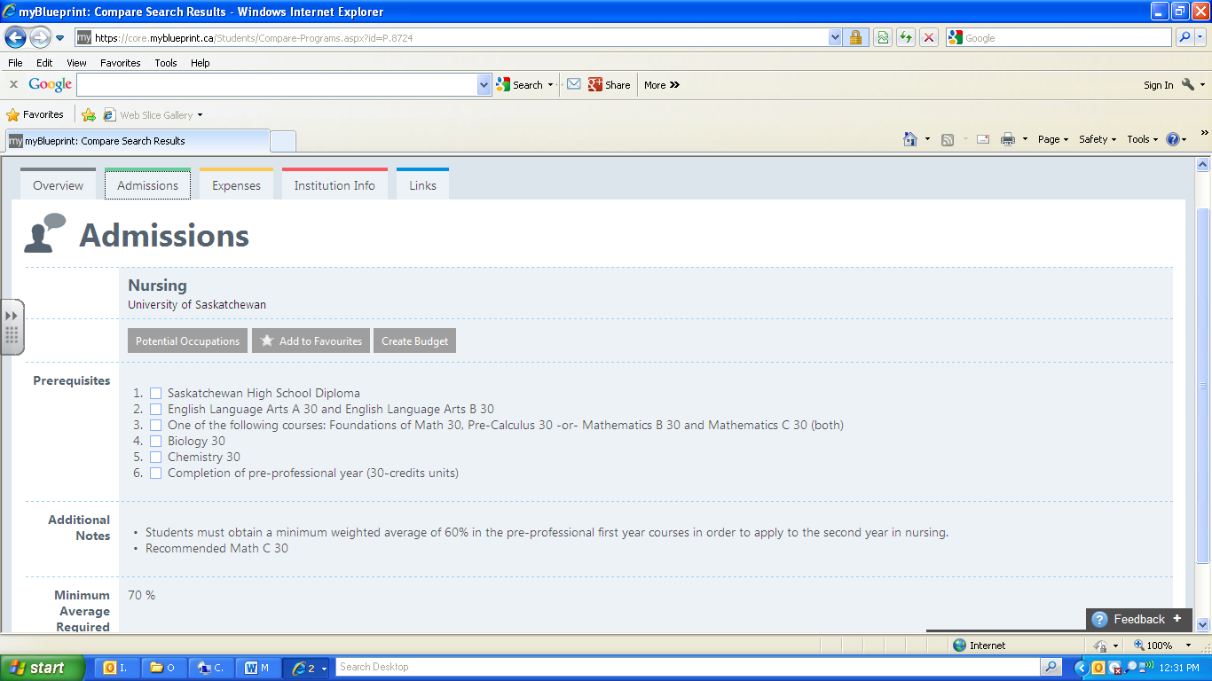
Click on “Expenses” (Shows You How Much It Costs)
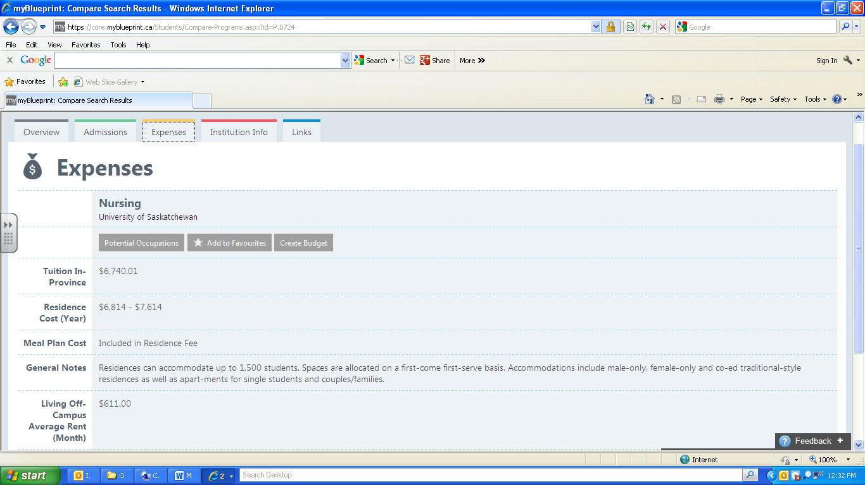
Click on “Institution Info” (Tells You About the University)
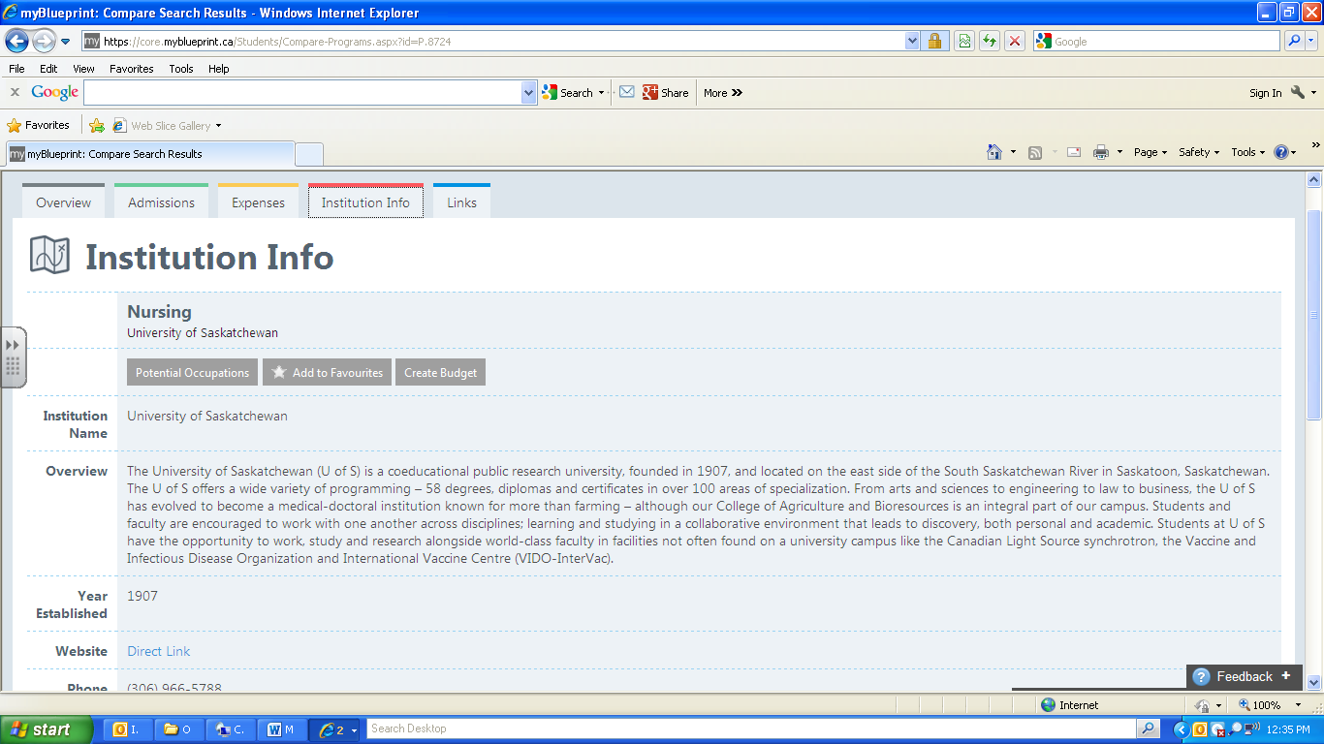
Add It To Your Favorites (Students Are to Select Three Favorites). You are able to print or email all information.
