Modifying Default File Location:
Select File and Options

Select Advanced and then File Locations from Bottom of Pop Up
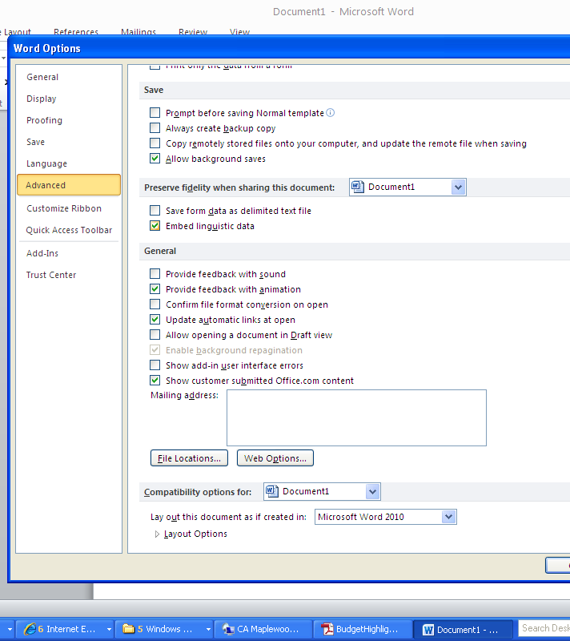
Select Documents and Modify to choose H: drive. It will then default to H: Whenever you go to file menu.

