How to Apply A Comment to Multiple Students

- Go to “enter comments and review report cards)

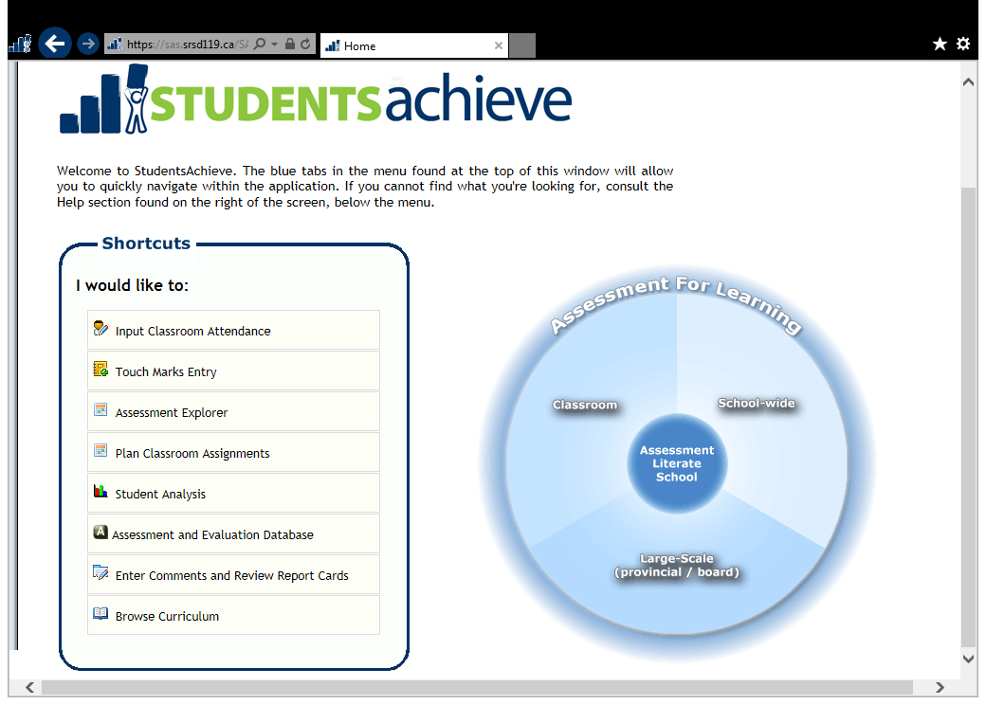

- Select “enter marks/comments by class”

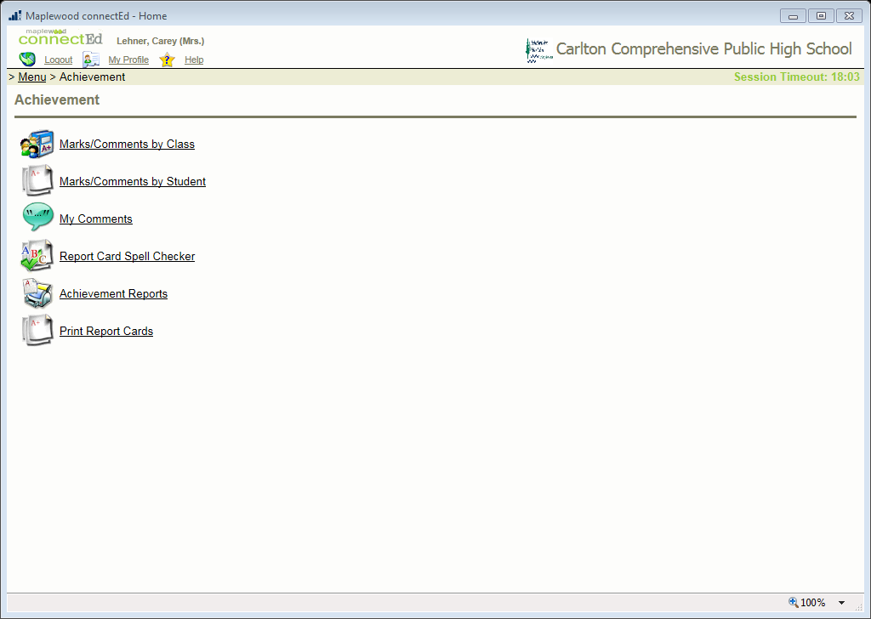
- Click on the heading of the column where your comments would be entered (for grades 10 – 12 this is the “grade” column, for grade 9 it is the title of your class column)
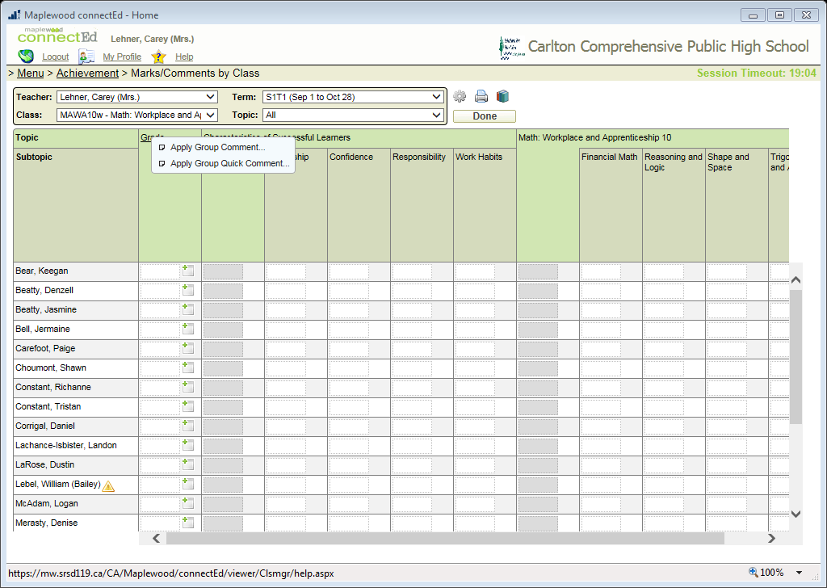

- Select “apply group comment”

- Type your comment here. There are instructions in the students achieve manual on page 42 on how to use the context sensitive word menu. Once you have written the comment, select “continue”
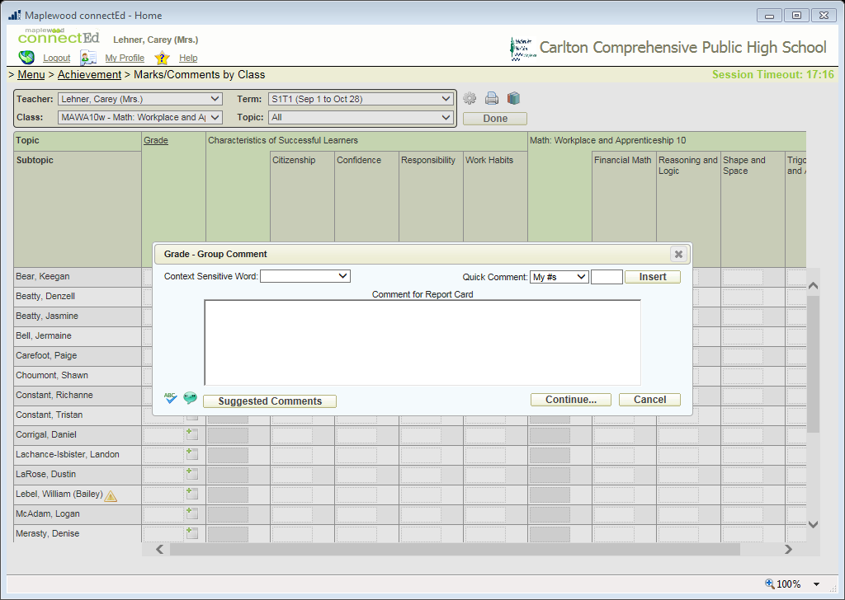

- Select the students you want the comment to be applied to, you can also select all. Determine where you want the comment to go. Select apply.
