How to Apply A Comment from your comment bank to Multiple Students

- Create your comment in a comment bank (see the instructions on how to do this)
- Go to “enter comments and review report cards)

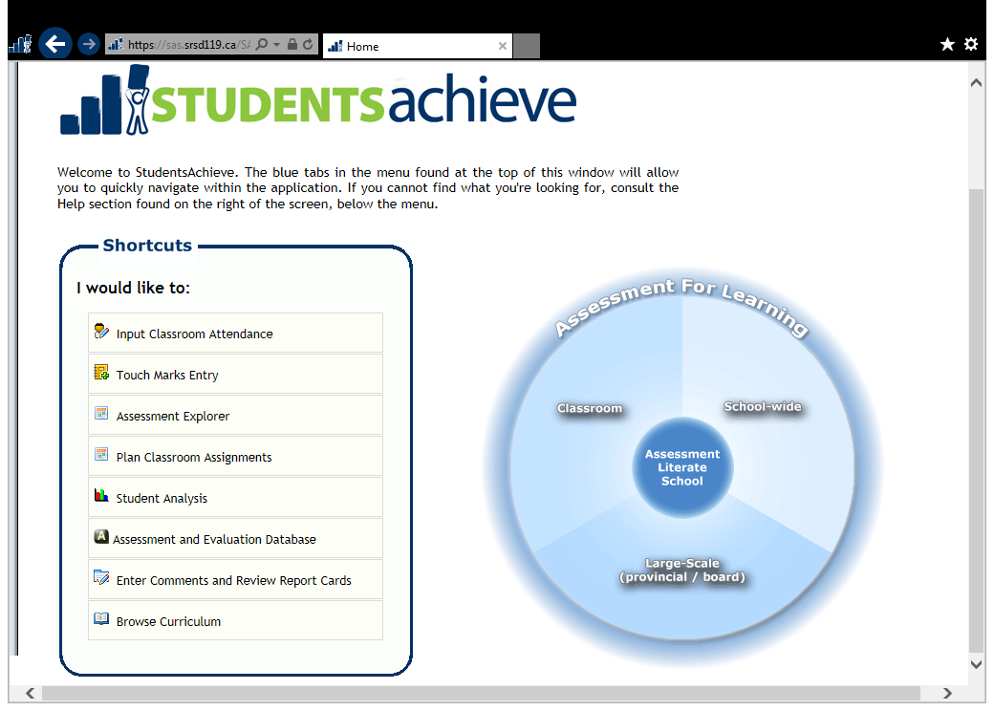

- Select “enter marks/comments by class”

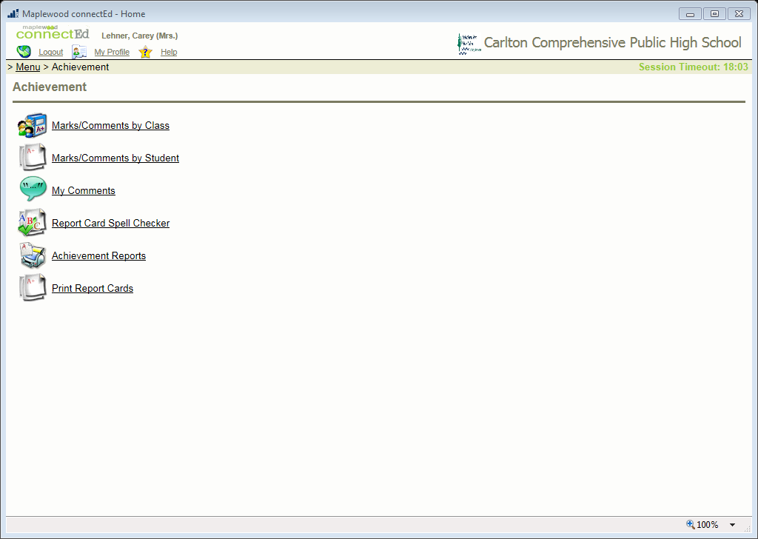
- Click on the heading of the column where your comments would be entered (for grades 10 – 12 this is the “grade” column, for grade 9 it is the title of your class column)
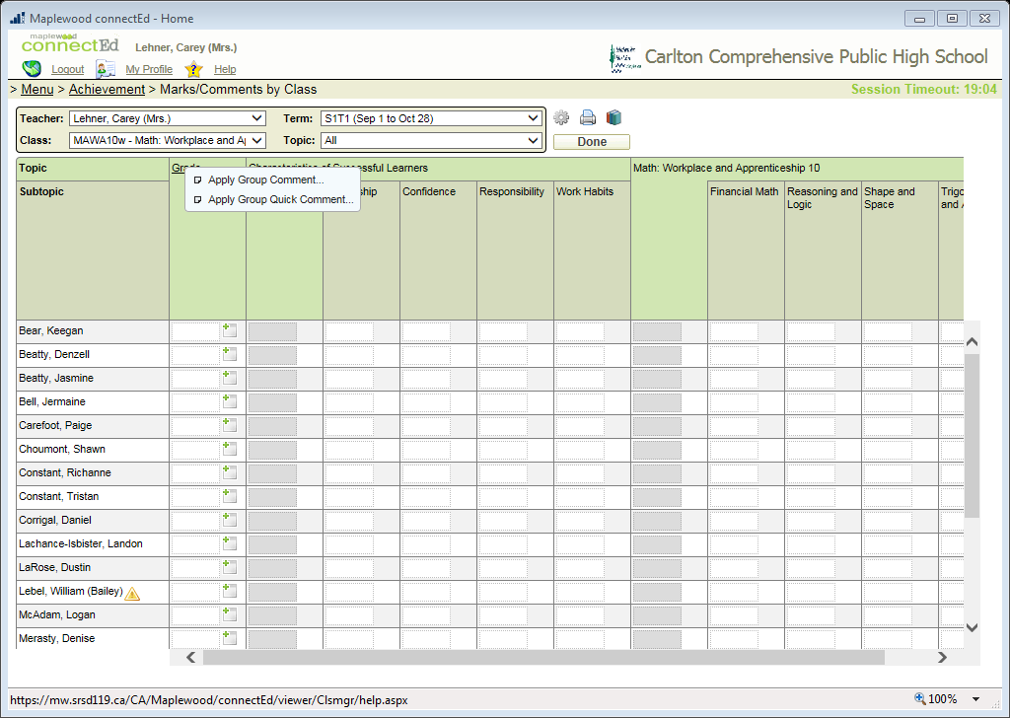

- Select “apply group comment”

- If you know the number of the comment you want to use, just type it here, or if you want to look through your comments, click here. Once you choose the comment, select “insert”, then “continue”
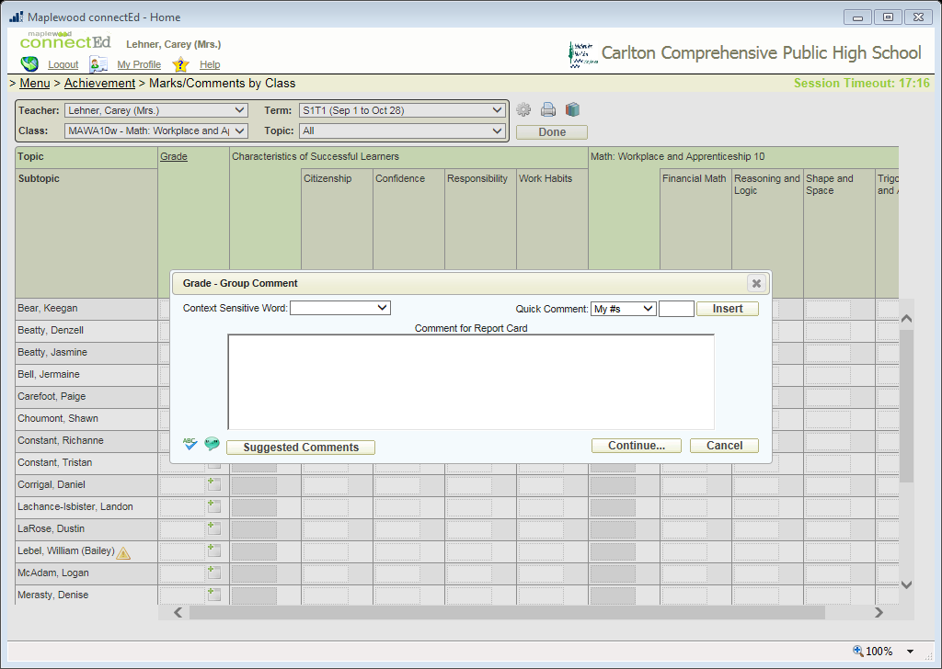

- Select the students you want the comment to be applied to, you can also select all. Determine where you want the comment to go. Select apply.
