Creating A Bank of Your Own Comments

- From students achieve, click on “enter comments and review report cards”

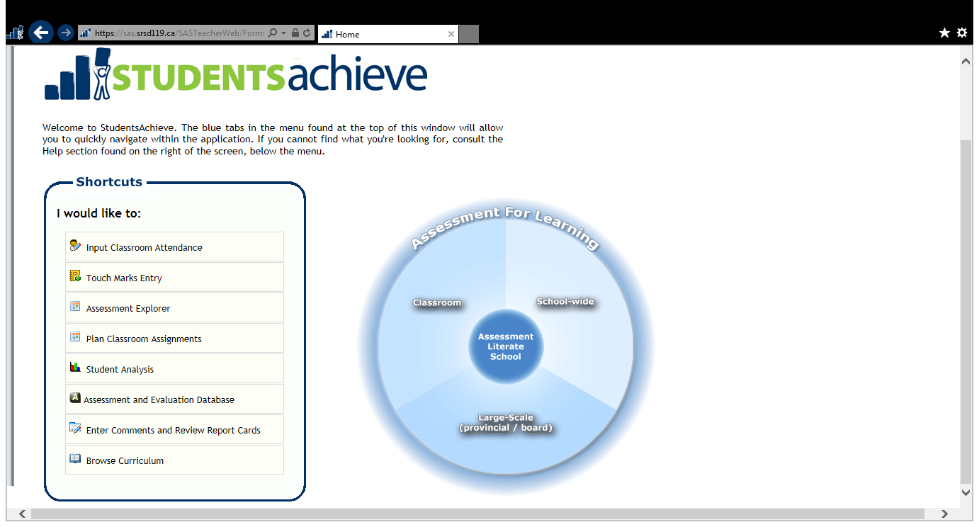

- Select “my comments”

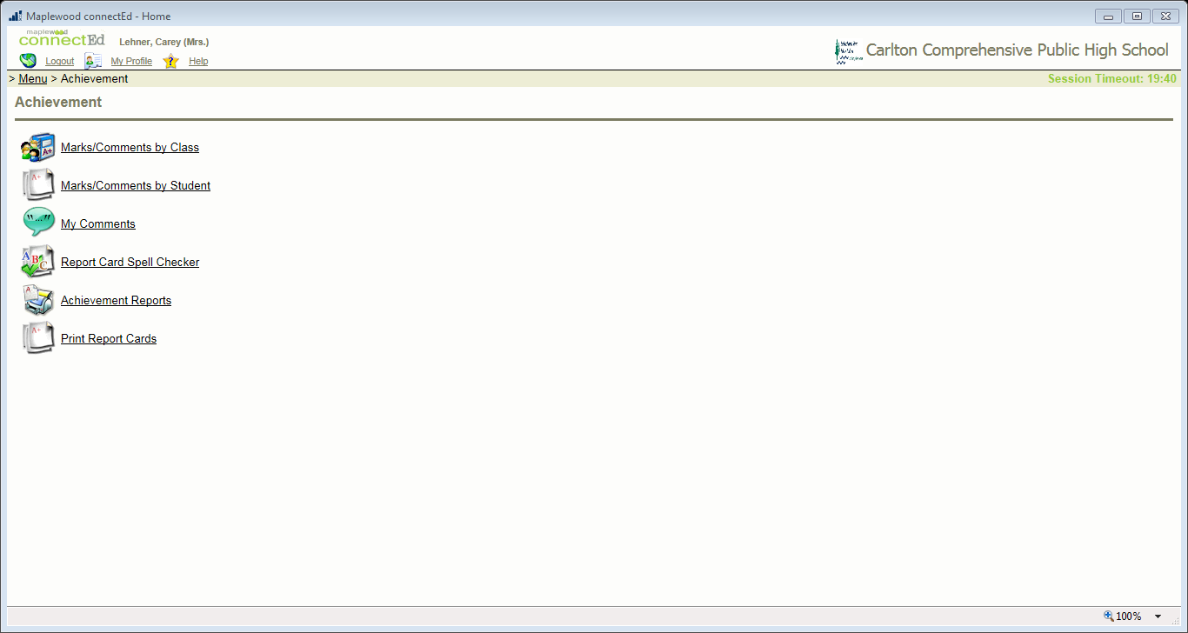

- Select “add new”
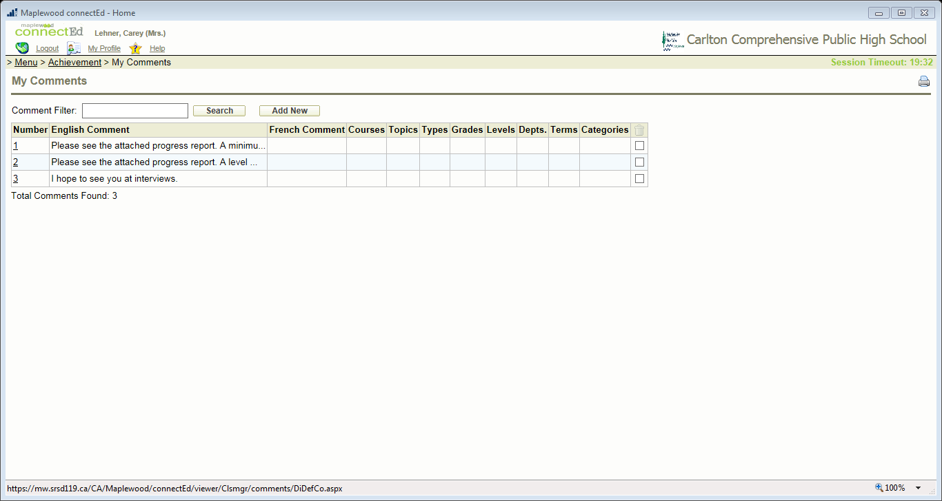

- Write your comment and then select “Save changes and go back”

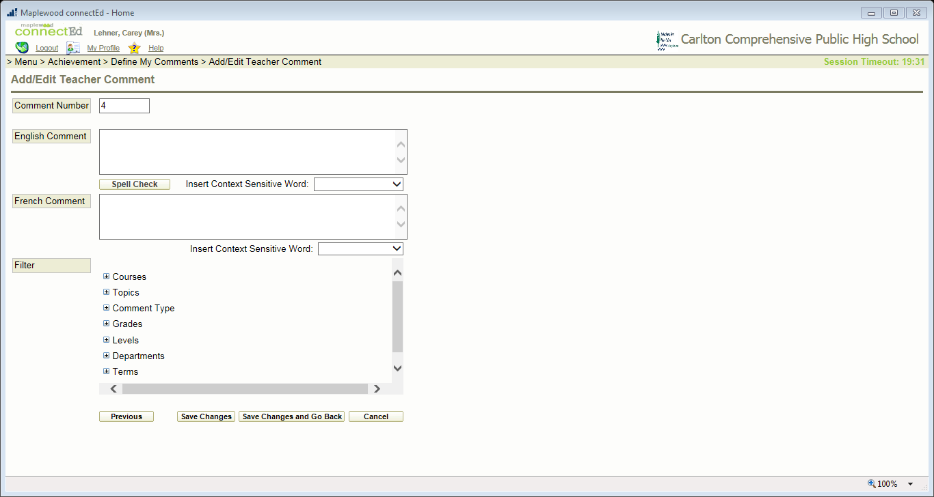
- This is the comment number for insert purposes

- If you want to print your comment bank, click on the print icon
